**CSE421 LAB 2   
  
Screenshots of the outputs for different data sizes**

For 128 bytes :   
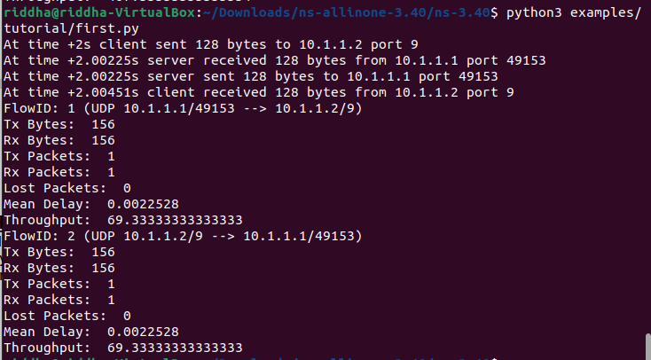

For 256 bytes :

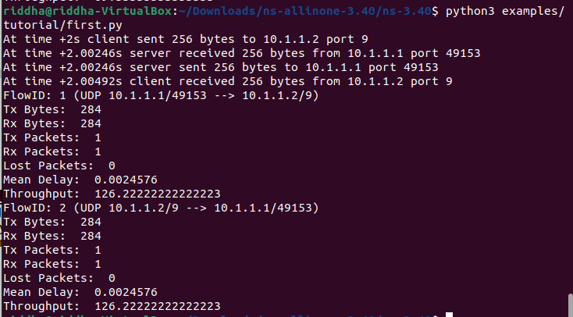

For 512 bytes :

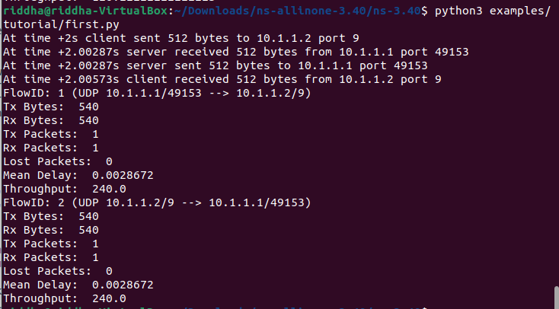

For 1024 bytes :

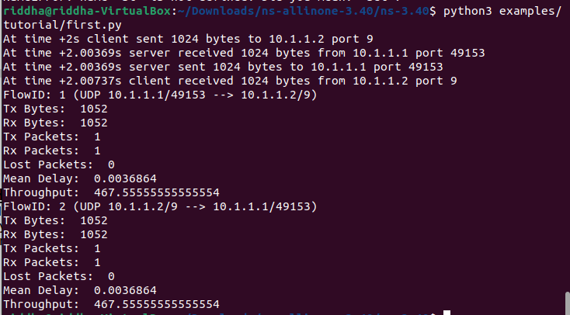

For 2048 bytes :

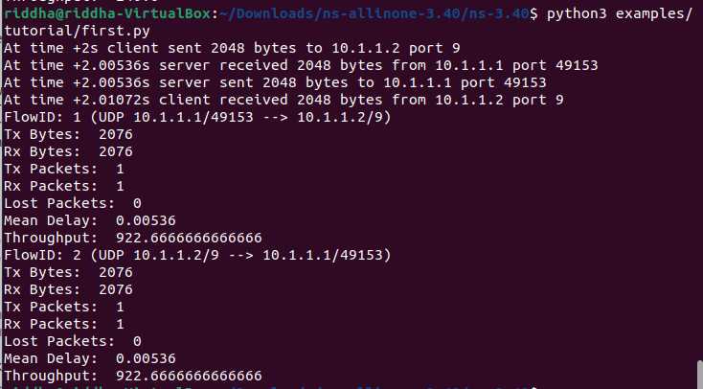

**A throughput vs data size graph**

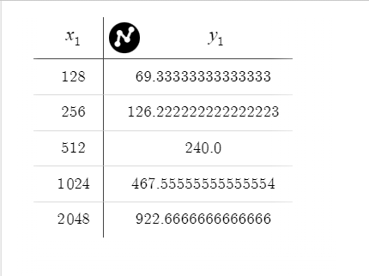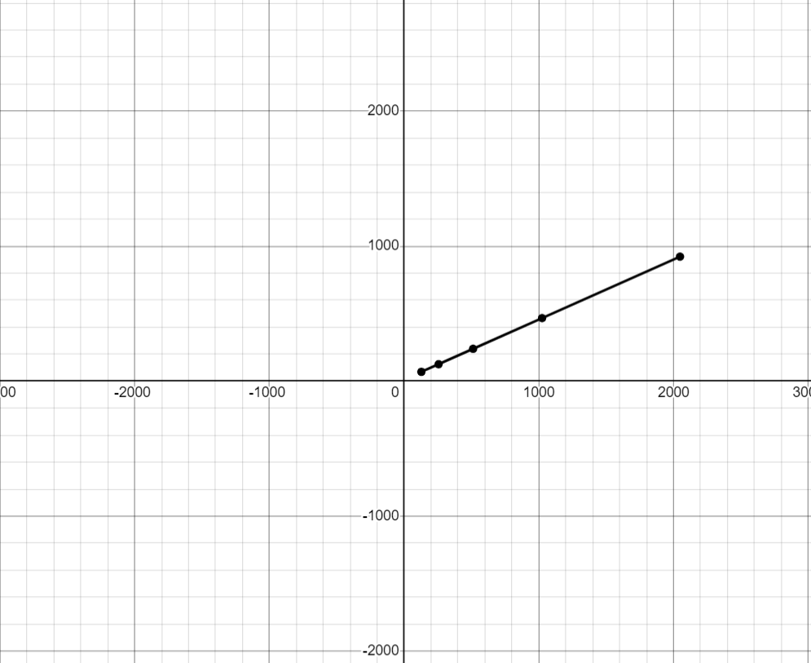

Here, in the graph we get a linear straight line. In the graph, throughput is set in the y axis and the data sizes are in the x axis. As the data size increases, the throughput also increases.